**Project Development Phase**

|  |  |
| --- | --- |
| **Date** | 02 November 2022 |
| **Team ID** | PNT2022TMID17964 |
| **Project Name** | Skill/Job Recommender Application |

**LOGIN PAGE:**

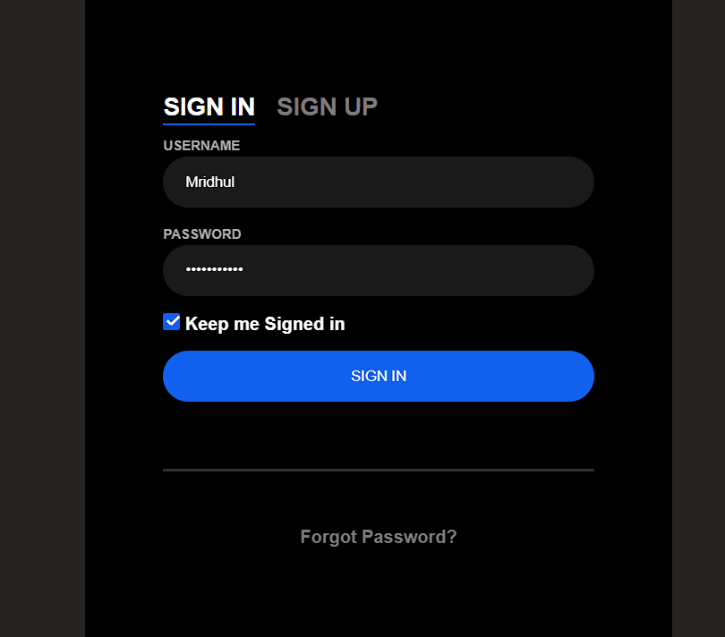

**SIGNUP PAGE:**

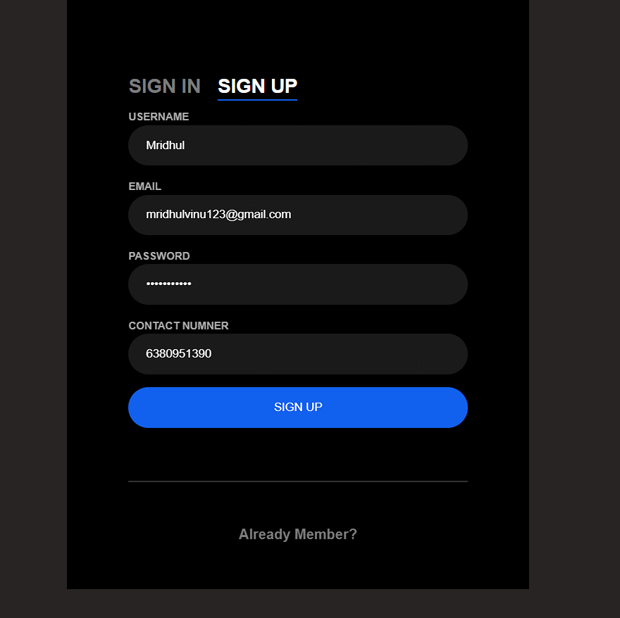

**PRODUCT PAGE:**

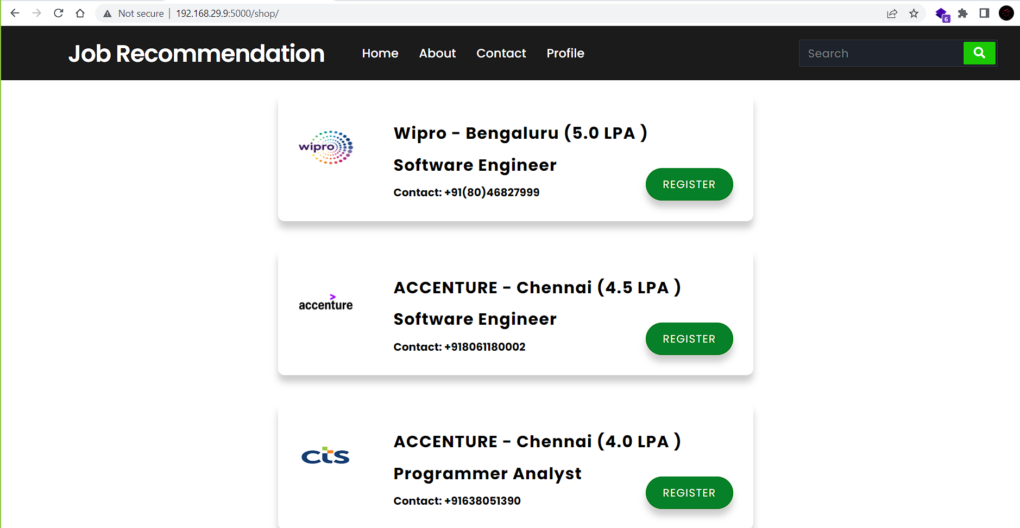

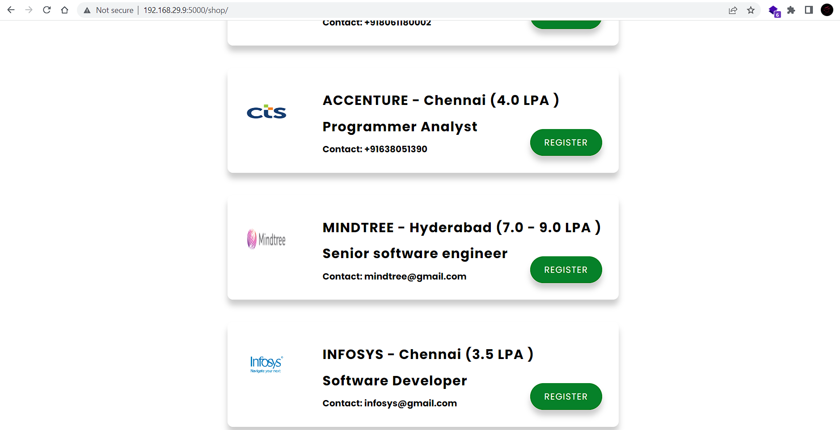

**DATABASE CONNECTION:**

